VARIATION IN INCINERABILITY OF MUNICIPAL SOLID WASTE IN INDIAN CITIES
Roshni Mary Sebastian¹, Dinesh Kumar², Babu Alappat³
Research Scholar, Department of Civil Engineering, IIT Delhi, New Delhi-110016, India¹
Assistant Engineer, North Delhi Municipal Corporation, New Delhi- 110002, India²
Professor, Department of Civil Engineering, IIT Delhi, New Delhi-110016, India³
roshnimary@gmail.com ¹ , dineshkathpalia@gmail.com ² , bjalappat@yahoo.com ³
------------------------------------------------------------------------------------------------------------
Abstract: Municipal solid waste (MSW) management has become a challenging task in India for local government authorities and concerned private agencies and non-governmental organizations (NGOs) due to the quantum and heterogeneity of the waste generated. With waste generation increasing at alarming rates and segregation at source remaining an unattainable task, there is an imminent demand for an integrated waste management strategy. Biological treatment techniques like composting have perhaps become unfeasible as the primary treatment route owing to the long treatment durations spanning from at least 2-3 weeks to as high as 4-6 months. With daily generation rates as high as 9000 TPD in metros like Delhi, there is an evident need for a faster treatment technique while ensuring energy and material recovery. As a result, waste incineration has perhaps, emerged as an undisputable element of integrated waste management system owing to shorter treatment durations and low space requirement, as opposed to conventional practices like composting and landfilling. However, being a technology with high monetary requirements, it becomes mandatory to ensure its feasibility to prevent operational failures. While detailed composition and characterization studies can facilitate this decision making to an extent, experimentation becomes tedious and erroneous. To expedite the decision making process, a composite indicator, the i- Index has been formulated by the authors which can quantify the incinerability of the MSW, and thus the feasibility of waste incineration process for waste disposal. The index incorporates the potential environmental impact, energy recovery and fiscal aspect of waste incineration process in the decision making. The current study is focused on the application of the i- Index for estimating the incinerability of MSW generated in Ahmedabad, Patna, Bengaluru and Lucknow, cities whose MSW generation rates have increased by nearly 42.5%, 82.7%, 26% and 20% from 2011 to 4000, 1277, 5000 and 1500 TPD, as per latest reports from local government authorities. With urbanization and economic growth increasing the MSW generation furthermore, the quantification of incinerability of MSW from the study areas can help devise appropriate treatment and disposal strategy to handle the mounting MSW. The study shall also help derive an incinerability based ranking of MSW generated in the study areas.
Keywords: Municipal solid waste, incinerability, waste incineration.
------------------------------------------------------$\text{∴∴∴}$--------------------------------------------------

I INTRODUCTION
Thermal treatment of MSW has gradually become an irreplaceable element of integrated solid waste management owing to escalating MSW generation rates. Increasing population density, improved economic growth and unhindered urban migration have collectively contributed to mounting MSW (Karak et al., 2012). The scenario is particularly acute in developing countries like India, due to the composition and characteristics of the generated MSW. Annual MSW generation is at 62 million tonnes in India and the per capita waste generation is bound to increase from 0.35 kg/capita/day to 0.7 kg/capita/day by 2025 (Hoornwerg and Bhada-tata, 2012). Higher organic fraction necessitates biological treatment of the MSW; the landfilling of organic fraction is completely restricted as per Solid Waste Management Rules, 2016. However, open and unscientific dumping of MSW continues to be a common practice. Besides environmental and health related problems, it affects the aesthetics of the area. Furthermore, greenhouse gas (GHG) emission from open dumping of MSW is deemed to be significantly higher than the GHG released from incineration of MSW. Biological treatment techniques like composting and anaerobic digestion convert the MSW feed to beneficial by-products; however, the treatment duration makes it unfavorable as the primary treatment route in developing countries due to high daily generation rates. With the rising prominence of incineration of MSW for treatment and disposal, it has become quintessential to assess the incinerability of the feed. Incinerability of MSW may be defined as the amenability of the MSW to be burned completely to sterile ash, with optimum energy recovery, minimal environmental impact and economic sustainability (Sebastian et al. 2017). With the increasing significance of waste incineration for treatment and disposal of MSW, it becomes mandatory to estimate the incinerability of the MSW prior to the implementation of the technology.
Conventionally, incinerability assessment studies were performed using tanner diagram, which is a diagrammatic representation of the proximate analysis. The vertex with 100% volatiles and null values for ash and moisture content indicated zone of maximum incinerability. If the position of MSW on the basis of its physical properties was out of the combustible zone, feasibility of incineration was concluded to be low. Figure 1 illustrates the zone of combustibility in tanner diagram. Another traditionally followed thumb rules relies on the heat content of the MSW feed to facilitate the decision making process. While a calorific value of less than 1500 kcal/kg was assumed to be indicative of poor incinerability, a calorific value of 2400 kcal/kg suggested autogenous incineration (Rand et al., 2000). However, these were based on assumptions and incorporated only the prospects of energy recovery from MSW incineration.
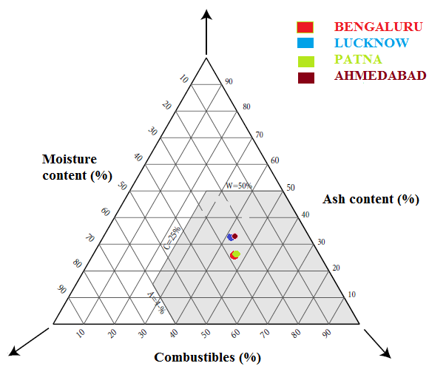
Figure 1 Tanner diagram for feasibility assessment of waste incineration
The primary objective of waste incineration being waste disposal with minimal environmental impact, such practices for incinerability assessment were feeble, to some extent. To overcome this drawback and to simplify the incinerability assessment studies, a unique composite indicator named incinerability index or i- Index was developed by the authors. In addition to quantifying the incinerability of MSW, i- Index may be used to determine the feasibility of waste incineration for a particular city. It may thus be used while framing integrated waste management strategies. Further, it may also be used to study the variation in incinerability of MSW over the years or across different seasons. Such studies can minimize failures of waste to energy (WtE) plants. Numerous waste to energy plants lie idle across the world, due to faulty assumptions in waste characteristics. India’s first WtE plant in Timarpur, Delhi is one such instance wherein despite a state of the art design and infrastructure, the plant was shut down after a few weeks of operation due to poor heat content of the waste feed.
The study here is aimed at demonstrating the application of i- Index, by estimating the incinerability of MSW generated in cities like Ahmedabad, Lucknow, Bengaluru and Patna. The relative variation in the incinerabilitites of MSW generated in the study areas shall be projected.
II STUDY AREAS
The formulation of waste management strategies is primarily depended on the quantity and the characteristics of the MSW (Karak et al., 2012). While Ahmedabad and Bengaluru being major metros recorded high MSW generation rates of 4000 and 5000 TPD, Lucknow and Patna being smaller cities had relatively lower generation rates of 1500 and 1277 TPD (Arun et al., 2010; Francis et al., 2013; Archana et al., 2014; Bhanu and Kumar, 2014; Ahmedabad Municipal Corporation, 2015). Figure 2 shows the areas under study. The combustible fraction in the MSW generated in Ahmedabad and Bengaluru were marginally higher than the other two cities, due to higher economic growth in the former. Figure 3 shows the composition of MSW generated in the study areas (CPCB, 1998). Inert and food fraction constituted an alarming portion of the generated MSW in all the study areas. Waste segregation however, is still an unattainable task in Indian conditions and hence, a highly heterogeneous MSW is available as feed to all treatment facilities.
Landfilling had been the primary disposal route in all the study areas with more than 60% of the MSW being landfilled; this has gradually become an unfeasible route owing to the acute shortage of land availability. While composting and RDF production is practiced in Bengaluru and Ahmedabad, Lucknow and Patna has no operational composting or WtE energy facilities currently. Proposals have been made at municipality level to encourage private and public partnerships (PPP) for efficient collection and segregation of wastes.
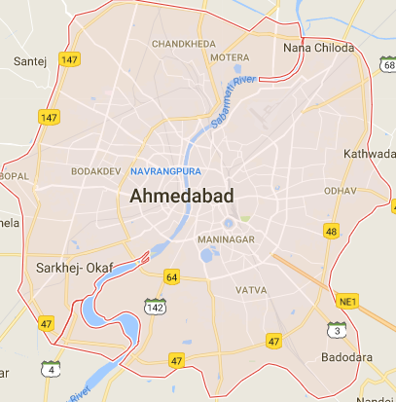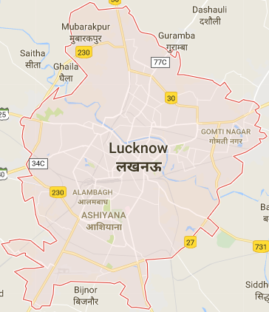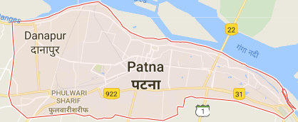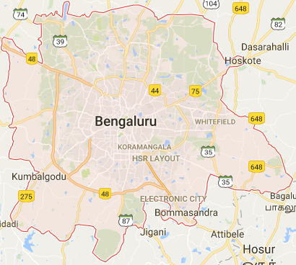
Figure 2 Study areas (a) Ahmedabad (b) Lucknow (c) Patna (d) Bengaluru
Further, the choice of the treatment techniques may be decided up on depending on various technological and socio-economic factors.
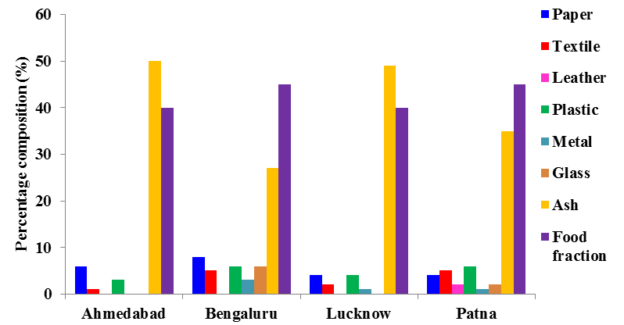
Figure 3 Composition of MSW generated in the study areas
Biological treatment is an environment-friendly treatment option as opposed to other techniques. Waste incineration has high pollution potential and requires high operational and maintenance costs. However, the ability of the technique to reduce waste volumes by almost 90% in a matter of few minutes to an hour or so with an added benefit of energy recovery makes it indispensable in the present

scenario. However, the choice of the technology can be made after estimating its incinerability, which in turn may be simplified using the i- Index.
III ESTIMATION OF INCINERABILITY OF MSW USING i- Index
The MSW generated in Ahmedabad possesses very low calorific value of 1000- 1200 kcal/kg, while that of MSW generated in Patna is reported to be 809 kcal/kg (Pandey, n. d.). While this alone cannot be the sole criteria for the choice of the technology, i-Index incorporates the prospects of energy recovery and economical aspects while taking into the account the pollution potential, when the particular MSW is used as the feed. A total of 8 parameters were chosen to reflect the comprehensive nature of incinerability of MSW. The relative weightage of the parameters was arrived at using analytic hierarchy process (AHP) (Saaty, 1977). Table 1 lists the parameters and their relative weightages. Graphs were developed to normalize the parameters to a uniform scale to aid in aggregation of the parameters to form a unique indicator. Following sensitivity studies, linear summation function was used to aggregate the parameters to determine the i- Index for MSW.
Incinerability Index or i- Index = 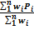 (1)
Where, Pi is the normalized values of parameters obtained from the graph and wi their corresponding weightages. i- Index for MSW is an increasing scale index, with a maximum value of 100, indicating maximum incinerability and minimum value of 1, indicating minimal incinerability.
Table 1 Parameters to determine i- index of MSW
Rank | Parameter | Relative Weightage
1 | SO₂ released per kg of MSW feed (mg/kg MSW) | 0.161
2 | Heat Content of MSW feed (kcal/kg) | 0.151
3 | CO₂ released per kg of MSW feed (kg/kg MSW) | 0.148
4 | Quantity of auxiliary fuel required to maintain 1000⁰C inside the furnace (kg/ton MSW) | 0.137
5 | % Volatiles in MSW feed | 0.124
6 | Specific heat of MSW feed (kJ/kg K) | 0.097
7 | Bulk Density of MSW feed (kg/m³) | 0.092
8 | % Moisture in MSW feed | 0.090
Total |  | 1.000

Table 2 : Values of input Parameters and the Corresponding Normlised

Parameter | MSW in Ahmedabad | Normalised value (P_{i}) | MSW in Bengaluru | Normalised value (P_{i}) | MSW in Patna | Normalised value (P_{i}) | MSW in Lucknow | Normalised value (P_{i}) | MSW in UK | Normalised value (P_{i})
Bulk Density (kg/m³) | 500 | 60.65 | 450 | 63.76 | 450 | 63.76 | 500 | 60.65 | 125 | 96
CO₂ (kg/kg MSW) | 0.95 | 65.3 | 0.96 | 65.1 | 1 | 62.92 | 0.955 | 65.2 | 1.25 | 53
Heat Content (kcal/kg) | 1326.6 | 42 | 1745.1 | 57.2 | 1725.7 | 56.3 | 1368.9 | 43 | 3282.3 | 94.2
Moisture Content (%) | 25.41 | 77.7 | 27.07 | 77.1 | 27.45 | 76.7 | 25.35 | 77.7 | 20.5 | 80.3
Auxiliary Fuel (kg/T MSW) | 91.3 | 17.8 | 69.75 | 25.6 | 78.8 | 20.6 | 87.03 | 17.3 | 11.5 | 76.5
SO₂ (mg/kg MSW) | 3.72 | 28.58 | 3.65 | 28.68 | 4.04 | 20.8 | 3.74 | 27.8 | 2.46 | 61.7
Specific Heat (kJ/kg K) | 2.14 | 47 | 2.24 | 40.2 | 2.22 | 42.1 | 2.13 | 45.9 | 2.11 | 47.0
Volatile Content (%) | 41.7 | 43.3 | 45.42 | 51.6 | 45.8 | 51.9 | 41.5 | 42.3 | 60.8 | 74.9
Note: P_{i} is obtained from the normalisation curves and hs no unit.
IV VARIATION IN INCINERABILITY OF MSW ACROSS DIFFERENT CITIES
Table 2 shows the values of input parameters collected from various published reports and the corresponding normalized values, obtained from the normalization curves. Figure 4 illustrates the i- Index for MSW computed thereafter. The i- Index for MSW generated in the United Kingdom (UK) has been computed to draw a comparison between the incinerability of MSW generated in a developed country and that in a developing country. The combustible fraction in the MSW generated in Patna and Bengaluru was 17% and 19%, while MSW generated in Lucknow and Ahmedabad had nearly 90% of inert and food fraction.
This increased the moisture content and subsequently lowered the net calorific value in the latter. Moreover, the potential SO₂ that may be released per kilogram of the MSW feed is also stipulated to be high when the food fraction is high. This is apparent from the i- Index values also. While MSW generated in Bengaluru had the highest i- Index of the 4 study areas that generated in Lucknow had the least. This is demonstrated in Figure 4 also. MSW generated in developed country like UK is composed of a large fraction of combustibles and low organic fraction.

Consequently, the i-Index is considerably high, connoting to highly incinerable MSW.
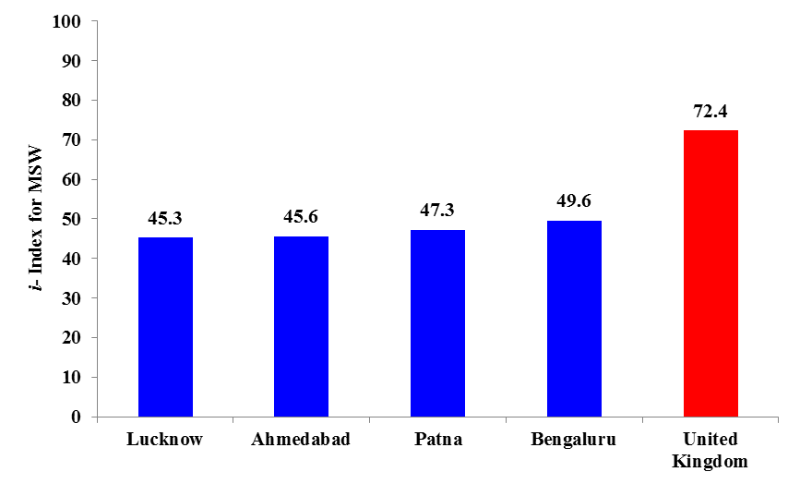
Figure 4 i-Index values for MSW generated in the study areas
Waste incineration may not be a feasible option when raw MSW from the study areas is used as feed to the furnace, as evident from the i-Index values. i-Index can be used to determine the degree of pre-treatment required to raise the i-Index values and hence the incinerability of MSW. Segregating out the inert fraction, drying etc. can significantly improve the feasibility of the technology. The individual parameter rating can be used as an indication of the type and degree of pre-treatment operation required to improve the incinerability of a particular MSW feed.
V CONCLUSIONS
Incinerability assessment of MSW generated in different cities in India was performed using i-Index for MSW. The decision making was carried out by incorporating prospects for energy recovery, potential environmental impact and economical aspects of operation. While the i-Index for MSW generated in Bengaluru had a relatively higher value of 49.6, that of the MSW generated in Lucknow is 45.3. However, the i-Index values of MSW were very low in comparison to that of the MSW from a developed country like UK, which confirms the disparities in the incinerability of MSW generated in a developed and developing economy. While pre-treatment operations like segregation of inert components and drying can improve the incinerability of the MSW generated in the study areas, individual parameter ratings can be relied upon to determine the degree of pre-treatment required to improve its incinerability. i-Index is a unique composite indicator for incinerability of MSW and can be used to decide the feasibility of waste incineration as a part of integrated waste management strategy. i-Index can thus facilitate the decision making minimizing operational failures of waste to energy plants.

REFERENCES
[1] T. Karak, R. M. Bhagat, P. Bhattacharyya, Municipal Solid Waste Generation, Composition, and Management: The World Scenario. Crit. Rev. Environ. Sci. Technol (1509-1630), Volume 42, 2012.
[2] D. Hoornweg and P. Bhada-Tata, “A Global Review of Solid Waste Management” World Bank Urban Dev. Ser. Knowl. Pap. World Bank, Washington DC, USA, 2012.
[3] R. M. Sebastian, D. Kumar and B. J. Alappat, “A Technique to Quantify Incinerability of MSW”, 2017.
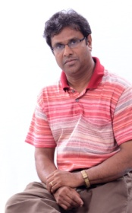
[4] T. Rand, J. Haukohl and U. Marxen, “Municipal Solid Waste Incineration”, World Bank Technical Paper No. 462, The World Bank, Washington DC, 2000.
[5] A. Arun, S. Shrishrimal and P.U. Antony, “Solid Waste Management in Bangalore City, Challenges and Possibilities - A Case Study with respect to Selected Locations”, Lake 2010: Wetlands, Biodiversity and Climate Change, 2010.
[6] R. P. Francis, L. P. Singh and E. V. Prakash, “Solid Waste Management and Characteristics in Lucknow, Uttar Pradesh, India”, International Journal of Scientific & Engineering Research (1645-1648), Volume 4, Issue 11, 2013.
[7] Archana, D. Ali, M. Yunus and V. Dutta, “Assessment of Status of Municipal Solid Waste Management (MSWM) in Lucknow- Capital city of Uttar Pradesh, India, IOSR- JESTFT (41-49), Volume 8, Issue 5, 2014.
[8] A.K. Bhanu and R. Kumar, “Strategy of Municipal Solid Waste Management- A Case Study of Patna”, IJCEBS, Volume 2, Issue 4, 2014.
[9] Ahmedabad Municipal Corporation, “Municipal Solid Waste Management”, Ahmedabad Municipal Corporation, 2015.
[10] CPCB, “Status of solid waste management in metro cities. Report. India”, Central Pollution Control Board, 1998.
[11] M. K. Pandey, “Solid Waste Management in Patna”, n.d.
[12] T. L. Saaty, “A Scaling Method for Priorities in Hierarchical Structures”, J. Math. Psychol. (234-281), Volume 15, 234–281, 1977.
BIOGRAPHY

Roshni Mary Sebastian holds a B.Tech (in Civil Engineering) from University of Kerala and M.Tech (in Environmental Engineering) from NIT, Surat. She is currently pursuing her PhD in Environmental Engineering from IIT, Delhi. She has also served as an intern at APC Division, NEERI Nagpur.
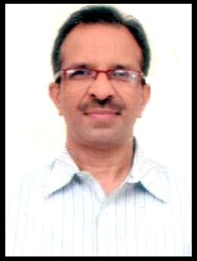
Dr. Dinesh Kumar graduated in Civil Engineering from Punjab University, did his M.Tech (in Environmental Science and Engineering) and Ph.D (in Environmental Engineering) from IIT Delhi. He has also worked as Research Associate at Department of Environmental Science and Engineering, University of Florida, USA. Currently he is working as Assistant Engineer at North Delhi Municipal Corporation, New Delhi. He has worked on Aerobic and Anaeobic Bioreactors in Florida. He has published over 30 research papers in International and National Journals and Conferences.

Dr. Babu Alappat holds a B.Tech (in Civil Engineering) from University of Calicut, M.Tech (in Environmental Engineering) from University of Kerala, Ph.D (in Environmental Engineering) from IIT Bombay and a Postdoc from Ecole Des Mines De Nantes, France. Currently, Dr. Alappat is a Professor of Environmental Engineering in IIT Delhi and a Visiting Professor in Ecole Des Mines De Nantes, France. He has got about 18 years of experience in research and teaching in the field of Environmental Engineering. He specializes on Incineration Techniques, Fluidized Bed Reactors and Solid Waste Management. He has published more than 100 research papers in International and National Journals and Conferences. He has guided several Ph.D and M.Tech projects. He is an expert consultant to many Governmental and Non-Governmental organizations like Central Pollution Control Board, Dept of Science and Technology, etc.

